EGR 314 18748

Team 207

1/18/2023

**User Needs, Benchmarking, & Requirements**

**Introduction:**

Our team has been tasked with a solution to counteract environmental conditions that can be solved using sensors and hardware components. We have analyzed existing products in the field of our project. From these products we have determined what customers prefer and what customers need. We have brainstormed a list of user needs that our product should meet.

## **Product Benchmarking**

## Selected products:

**1:** [**Ambient Weather WS-2902 WiFi Smart Weather Station**](https://a.co/d/1ZKFwxa)

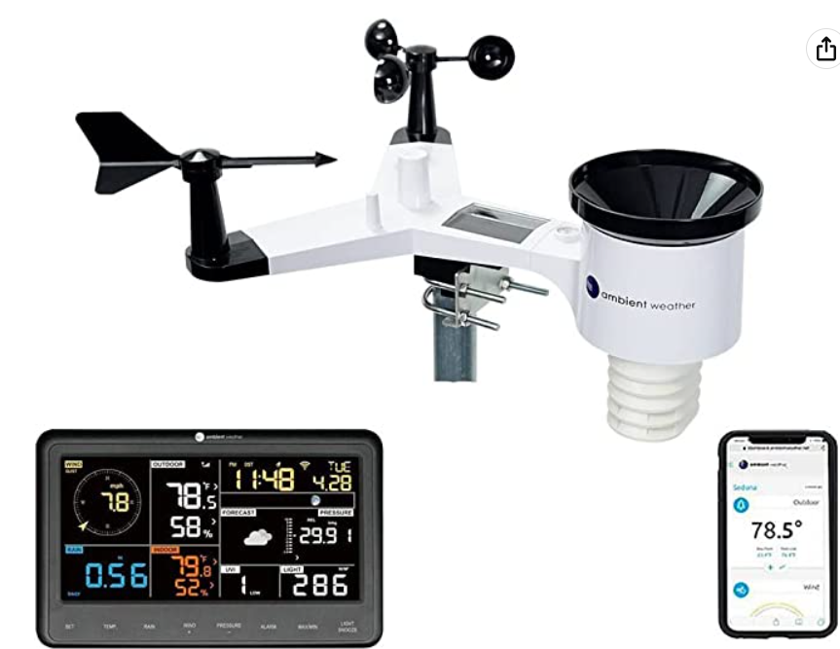

* Price: $189.99
* Vendor: Amazon
* Description: A device that allows users to monitor weather conditions through wind speed/direction, temperature, humidity, rainfall, UV and solar radiation. This data is transmitted wirelessly to Wi-Fi to your phone or tablet.

**Product Review:**

**Positive Comments**

| **Customer Comments** | **Restated Customer Needs** |
| --- | --- |
| All the weather information you’ll ever need. Large easy to read display. You’ll have to provide your own mounting pole or bracket to hold the station outside - make sure you buy one with the station. Very happy with this purchase. | * Information is easily accessible and legible |
| Installation and setup was a breeze and the ambient weather website and app are very impressive. The thing that I like the most is that you can set up alerts to trigger an email or text message on any metric that this device captures. | * Installation of weather deceive was simple |
| as described no problems | * performed just as advertised |

**Negative Comments**

| **Customer Comments** | **Restated Customer Needs** |
| --- | --- |
| I do not like that the weather station has a difficult time connecting to a mesh based home wifi system. It is recommended that you "turn off" all but your main puck and try to connect. This has not worked for me. | * Difficulty connecting to Wi-Fi * Problems with Setup of deceive |
| Called tech service 3 times the two days I have had this. On each call the hold time was over twenty minutes. The console is very hard to see in daylight. But-the biggest issue is the console keeps loosing power and resetting itself. I’m hoping replacement unit is better. | * Poor technical support * Power issues |
| I do very much like this weather station, however, my array (the outside part) failed after 378 days (just barely over the one year warranty). That's FAR too short a time for something like this this to last. I am NOT in a harsh environment | * Durability issues |

**2:** [**Home Alkaline Water Filtration System**](https://a.co/d/8Tt0fmA)

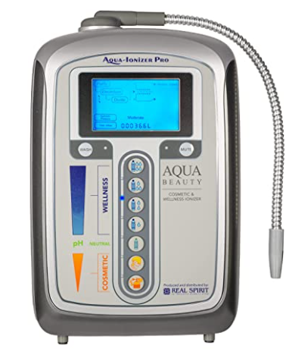

* Price: $934.99
* Vendor: Amazon
* Description: Has 7 different types of options for how water will be outputted, 1 non-ionized purified, 4 alkaline ionized continuously variable, 2 ionized acidic presets. The range of pH is from 4.5 to 10 and allows for uses regarding cleaning, cooking, drinking, ect. Self maintains itself so after 10 gallons it auto plate washing and reverses polarity.

**Product Reviews:**

**Positive Comments**

| Customer Reviews | Restated Customer Needs |
| --- | --- |
| Been using this for the last 6 months and the biggest difference I’ve seen is in my skin. I’ve always struggle with acne and breakouts even at 30 years old, and ever since I’ve started using this machine my skin has never looked better. | * Helped with personal health and appearance |
| I have done a lot of research on water electrolysis and this product is the perfect quality product at an amazing price point. What differentiates this company from the competition is the amazing customer service. I had some electrical issues after two years of ph adjusted water and one phone call with Mason fixed all my issues with this quality machine. He was patient and walked me through the whole troubleshooting and maintenance process that fixed a machine I thought might be defective. | * Great quality and price point * To fix/maintain device was easy with assistance |
| The water is great and has several setting that I enjoy. The only problem is that when I moved and installed it in the new home it leaks at the faucet and I have not been able to find a replacement online or by calling. | * Works as advertised * Seals have gone bad |

**Negative Comments**

| Customer reviews | Restated Customer Needs |
| --- | --- |
| The water is great and has several setting that I enjoy. The only problem is that when I moved and installed it in the new home it leaks at the faucet and I have not been able to find a replacement online or by calling. | * Leak and seal issues * Low modifications |
| Amount of money paid to own the machine is not worth it at all! | * overpriced |
| My natural water ph is 8.5. This only makes it max 9.5 and a low of 8.1! Total junk, fraud and now after multiple wayer testers oh strips know it’s the machine. Do not waster your money on this | * Not functioning as advertised |

Search #

Keywords: “plant blankets freeze protection”

Search Results Link: <https://www.amazon.com/s?k=plant+blankets+freeze+protection&sprefix=plant+blanket%2Caps%2C152&ref=nb_sb_ss_ts-doa-p_2_13>

3. [the Planket](https://a.co/d/b7o8F5c)

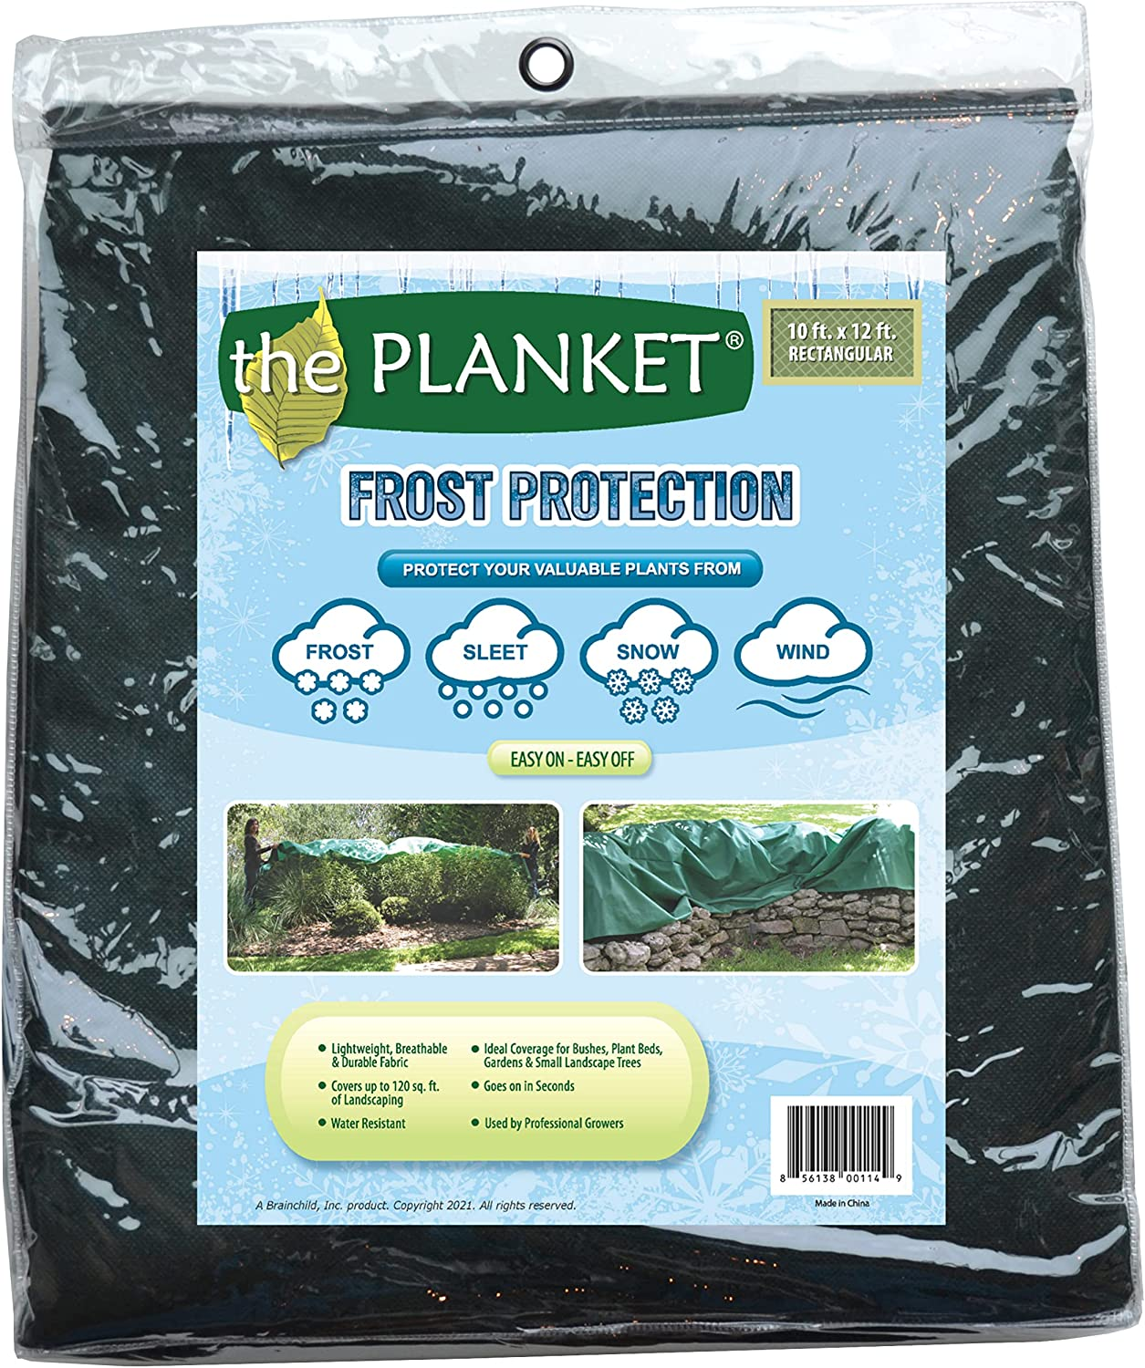

* Price $20.98
* Vendor: Amazon
* Description: Plant blanket that helps protect your valuable plants from frost, sleet, snow, and cold winds.

**Product Reviews:**

**Positive Comments**

| **Voice of the Customer** | **Restated Customer Need** |
| --- | --- |
| “We always purchase these covers to protect our plants from frost. These do a great job. They're also easy to fold and use. They're also light weight while at the same time being strong. We are very satisfied with the price as well. Recommend.” | * Easy to store (Explicit) * Easy to install (Explicit) * Affordable (Explicit) |
| “It won't completely shelter them if there is a wind and cold temperatures for a long length of time, but it will help. We have vegetable plants. I'll harvest what I can but they usually give a bit more time before the plants are done for... and then I can start again in the spring. But for my winter vegetables - lettuce, peas etc., they do offer enough protection.” | * Shelter plants for long time (Explicit) * Offers enough protection (Explicit) |
| “I recently had some crape myrtles pkanted. I wanted to make sure they did not when them temp was supposed to get down in the 20s. They were large enough and easy to use.“ | * Large enough to cover plants (Explicit) * Easy to use (Explicit) |

**Negative Comments**

| **Voice of the Customer** | **Restated Customer Need** |
| --- | --- |
| “Good for temporary use. I typically remove this "planket" when the sun is out and temperatures go above zero or 32 degs F. All plants need natural light, so prolonged use would have a detrimental impact on the plant etc.  This one comes with rings at the corner of the "planket" so you can secure it via pegs, or hooks etc. Those pegs are supplied separately.  Unfortunately the rings easily get torn out of the material when there is gusting winds of 10mph or more.  TIP: Don't use this as a ground sheet for weeds.” | * Remove product when sun is out and temperatures are above freezing (Latent) * Survive winds (Explicit) * Allow plants access to natural light (Explicit) |
| “Pro- very easy to install.  Cons- not durable in wind, grommets easily detach  This thing has already been ripped out of its grommets 2x. I resecured it, and it still is ripping up. We are having winds of 15-20 mph and it’s expected to ice over later. I guess whatever’s under the cover will live and the rest I will replace.  Maybe in a light snow where there’s not a lot of wind this would be great.  I don’t usually get snow, I got it for frost/ice. Likely returning.” | * Survive winds (Explicit) * Durable (Explicit) * Work with a range of weather conditions (Explicit) |
| “Lots of my plants were still burned by the freeze even though they were completely covered. DEFINITELY ineffective for any plants considered tropical. My elephant ear lost almost all of it's leaves, and both of my palm trees are having to be cut back to the stems. I knew there would be some damage on these but this is an unacceptable level of damage. Would need multiple sheets to actually be effective. Only saving grace is that none of my plants completely died.  On top of all of that, already has multiple tears as well after only a week and several of the plastic rings for staking down the sheet have come out. The ring placement is also not consistent throughout the entire sheet so there's just huge gaps that still have to have rocks put on them to prevent additional damage to plants, or to prevent a spot for wind to catch it and completely rip the entire sheet our of the ground.  As I said, no plants completely died but this is not a good product.“ | * Protect plants from freezing (Explicit) * Durable (Explicit) * Adhere to advertised features (Explicit) |

#### **4. EcoQube Greenhouse**

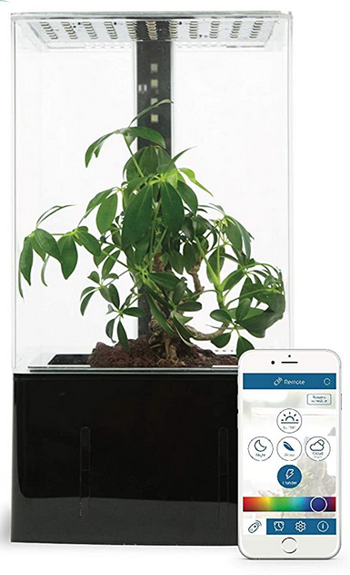

* **Price:** $110
* **Vendor:** Amazon  
  [Product Link](https://www.amazon.com/EcoQube-Greenhouse-Self-Watering-Hydroponic-Desktop/dp/B07PG5BNPP/ref=cm_cr_arp_d_bdcrb_top?ie=UTF8)
* **Description:** The EcoQube greenhouse is a self-watering hydroponic growing system greenhouse. The design includes LED lights and smart functionality. It is intended for indoor use as a decorative piece, while also functioning as a self-contained countertop garden system.

**Product Reviews:**

**Positive Comments**

| **Customer Comments** | **Emphasized Customer Need** |
| --- | --- |
| “This is a nice little greenhouse with bright lights. I think my only complaint is that it's a little sharp on the edges…” | * Product needs to be safe for users. (Explicit) * Product should be aesthetically pleasing. (Explicit) |
| “This is my second ecocube and my first production version. My original ecocube was from their first kickstarter campaign. This ecocube is the base model and does not come with the humidifier or UV.”  “Their is a companion app that allows you to adjust pump and fan settings. As well as set schedules for the lights. However while the app connects and is able to remote control the cube the schedule feature is broken.” | * Product should be explicit in features included or excluded. (Latent) * Product software needs to be fully functional and accessible for users. (Explicit) * Product software should include adjustable settings. (Latent) * Product needs a software update patching system. (Latent) |
| “This EcoCube helps you reconnect you back to nature. Like a full-size greenhouse, the EcoQube Air provides the perfect conditions for your plants. I like to grow my own herbs for cooking that I can’t get fresh easily while also looking great on my kitchen counter top. ( A great conversation piece for my guests!  I feel that is a relatively low cost option for interior planting, especially for those lazy gardeners like me that live in a big city. I also like that I don't have to check or add water daily to my plants. Once a month is all you need to add some water to the reservoir.  Overall, its a great mini green house in the privacy of your home or Apartment” | * Product should be visually appealing and reflect nature. (Explicit) * Product should be effective at keeping nominal conditions for plants. (Latent) * Product should be small enough to be used inside and act as a decorative piece. (Latent) * Product should be affordable. (Explicit) * Product should be low maintenance for users. (Explicit) |

**Negative Comments**

| **Customer Comments** | **Emphasized Customer Need** |
| --- | --- |
| “I blame the broken item on Amazon, otherwise it appears to be a quite well built item. However, it would be great to make it CRYSTAL CLEAR you cannot use this product with just any smart phone, but *must* have an iPhone to use the product.” | * Product should be able to interface with various smartphone options. (Explicit) * Product should be explicit in what smart phones it *is* compatible with. (Explicit) |
| “Light schedule doesn't work. Doesn't come with humidifier/fogger ( they discontinued it due to it causing mold and over watering plant).” | * Product needs to account for moisture buildup during use. (Explicit) * Product should have sufficient QA to ensure all features are working as intended. (Latent) |
| “I would give it zero stars if possible. Only grew mold and flies. I also tried using already established plants, Gardenia & roses using kokedama method. Died within a week. Money down the drain.” | * Product needs to have a reasonable lifespan. (Explicit) * Product should be explicit in what plants or growing methods are ideal for use. (Latent) |

**5. Indoor Herb Garden Kit with Grow Light | Smart Garden for Home Kitchen Windowsill**

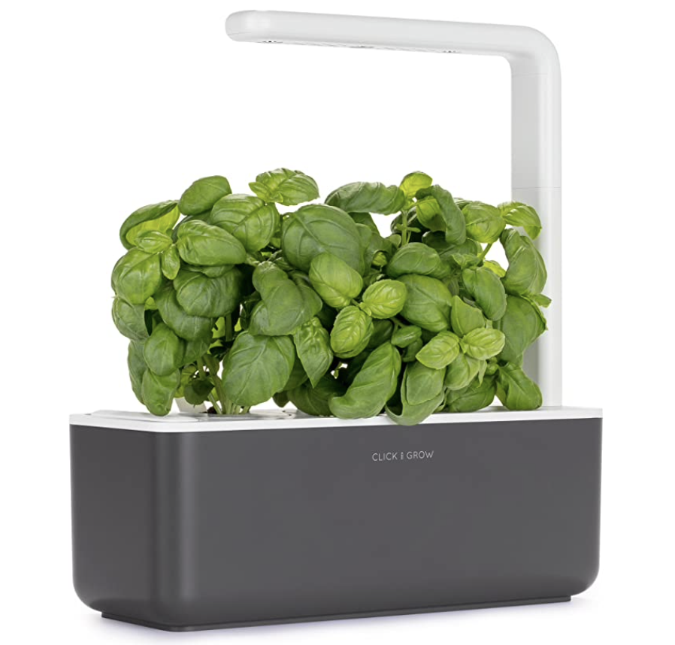

* Price: $99.95
* Vendor: Click and Grow
* Description: Grow Fresh Herbs and Vegetables Indoors: energy-efficient LED grow lights ensure your plants thrive no matter the weather.

**Product Reviews**

**Positive comments**

| Customer Comments | Emphasized comments |
| --- | --- |
| “I generally manage to kill house plants but this device gives me an automatic green thumb. The water reservoir eliminates the need to remember to water it; the grow light eliminates the need for direct sunlight.” | * No need to remember to water plants * Grow light eliminates need of sunlight |
| This product was a great introduction to gardening. I have since transplanted my chili peppers to proper pots, and take care of them myself. Click and Grow was almost like a gateway... I am a gardening nut now. But even so, I still use the Click and Grow as a starter. It's great for nurturing seedlings, and cloning (propagation). | * Great for beginners * Great for nurturing |
| It was easy to assemble and is well on its way to growing plants. | * Easy to use * Great to grow plants |

**Negative comments**

| Customer Comments | Emphasized Comments |
| --- | --- |
| This is my second time growing(six pods total) and each time they are covered in mold. I reached out to the company and they say it’s normal however; it is gross. The entire bottom and stem of the vegetables are covered in white mold. I cannot keep using this. Extremely disappointed | * High maintenance * Not great to grow plants inside |
| The product should not be considered a 'smart' product - the light is on a 16 hour timer and that's it. No ability to adjust the timer or monitor anything about the planter. | * Not smart, just a set time * Not versatile depending on plant |
| I followed the instruction very carefully but unfortunately I had to transplant the seedlings as they were dying. They never ran out of water or light. I have other pods to plant but I am not sure they also will wither and eventually die. I may also have to transplant them(!). I epuld not recommend buying these. | * Not great to grow plants * Needs to be tranplanted |

**Organizing User Needs:**

1. Rough breakdown of user needs based on customer reviews. This was done through a jamboard and identifying keywords or concepts that were present in the reviews.

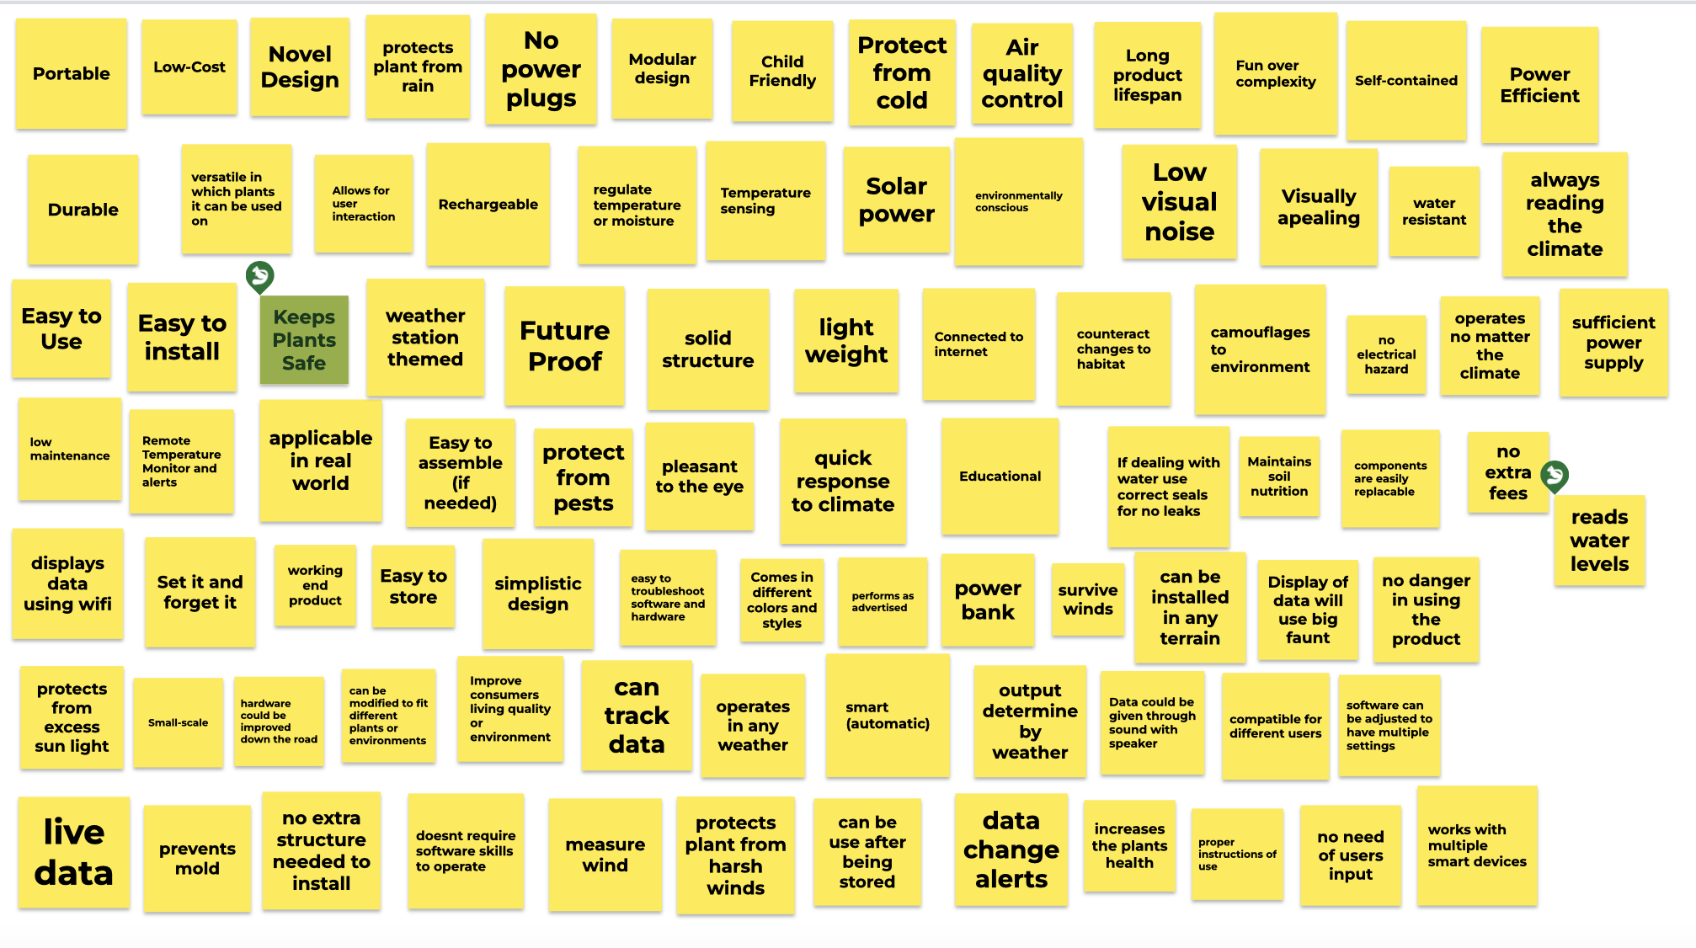

1. Grouping needs into subcategories based on key concepts.  
     
   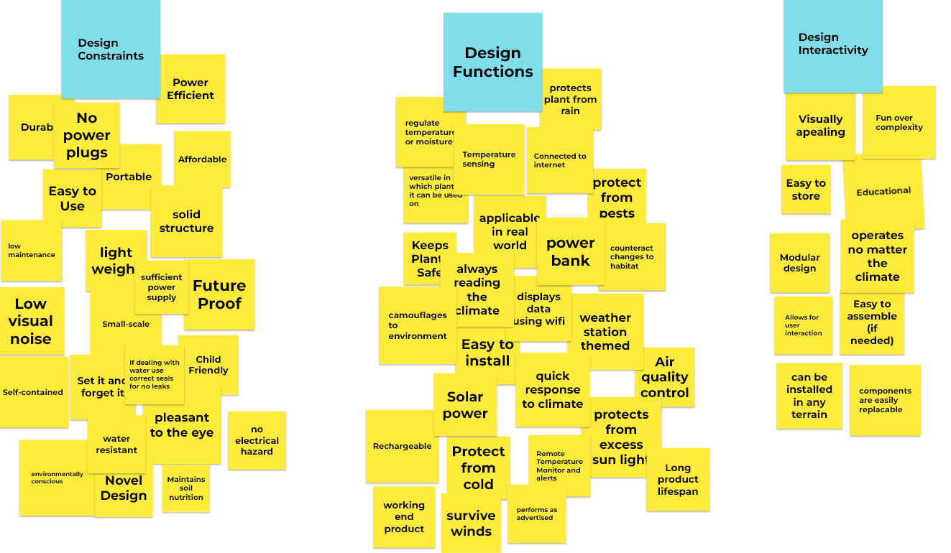
2. Ranking needs in a priority system of importance, where the lower number is more important to the final design.

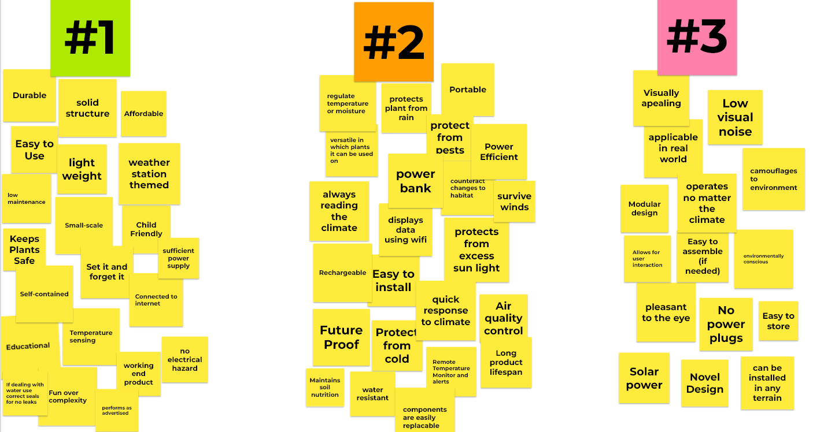

### **Developing Product Requirements:**

**User cases in different interaction examples:**

1. “Been using this for the last 6 months and the biggest difference I’ve seen is in my skin. I’ve always struggle with acne and breakouts even at 30 years old, and ever since I’ve started using this machine my skin has never looked better”
2. “This product was a great introduction to gardening. I have since transplanted my chili peppers to proper pots, and take care of them myself. Click and Grow was almost like a gateway... I am a gardening nut now. But even so, I still use the Click and Grow as a starter. It's great for nurturing seedlings, and cloning (propagation).”

**Design aspects:**

* Hardware / Product Design: System will need 2 separate serial sensors and a serial actuator using SPI or I2C. Also utilize 1 motor or linear actuator to control direction in multiple directions based on serial sensors. Powering of this system will be using at least one switching voltage regulator in the final design.
* Software / Functionality: Communication from board to web will be through WiFi. Data will be displayed to the user in real time when changes are occurring to the environment via sensors.
* Interactivity & User Experience: Once the user sets the product, the product will be able to automatically adjust to the surrounding weather so that the customer does not need to manually adjust the product.
* Customization: The user can set a desired output so that the product adjusts to the user's needs. The product can also come in different sizes and colors depending on the user preference.
* Manufacturing: the product will be made through a unique Printed Circuit Board that fits the sensors and actuators used in the product. There will be a casing to protect all components and make it easier to install.
* Safety: Product will use correct seals if dealing with water to prevent hazards. Also will keep electrical components secured within a solid zone to prevent shortages and prevent dangerous environments. Cords or power supply will have proper hardware to ensure no user is electrocuted.